**Anomaly Detection Using Pycaret**

PyCaret’s Anomaly Detection Module is an unsupervised machine learning module that is used for identifying rare items, events or observations which raise suspicions by differing significantly from the majority of the data. Typically, the anomalous items will translate to some kind of problem such as bank fraud, a structural defect, medical problems or errors . This module provide several pre-processing features that prepares the data for modeling through setup function. This module has over 12 ready-to-use algorithms and several plots to analyze the results of trained models.

<https://github.com/krishnaik06/Anomaly-Pycaret/blob/master/Untitled.ipynb>

**Anomaly Detection**

<https://github.com/akpythonyt/ML-algorithms/blob/main/Anomaly%20Detection%20%20.ipynb>

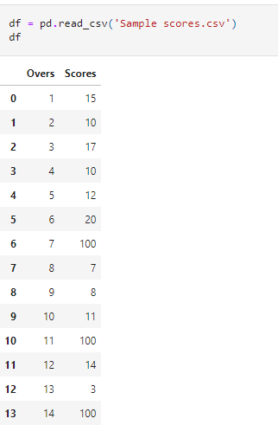

# **Anomaly Detection On IP Address Data - An Example using Gaussian Mixture Modeling (GMM) Clustering**

1. Extract source and destination IP addresses from a network traffic data of millions of packets.

2. Feature extraction from IP addresses and apply PCA to reduce dimensions to help clusters visualization.

3. Use Gaussian Mixture Modeling (GMM) Clustering algorithm to group similar IP addresses in to different clusters.

4. Find Anomalies/Outliers from the clusters of IP addresses by filtering based on location densities.

5. Try K-Means Clustering to compare with GMM.

6. Conclusion.

<https://github.com/raja-surya/Anomaly-Detection-IP-Address/blob/main/IP-Address-Anomaly-Detection-GMM-Clustering.ipynb>

**PYCART**

<https://pycaret.org/anomaly-detection/>

**YOUTUBE LINK**

[**https://www.youtube.com/watch?v=Q7YGBwKVpds**](https://www.youtube.com/watch?v=Q7YGBwKVpds)

[**https://www.youtube.com/watch?v=kbssBdFf764&t=668s**](https://www.youtube.com/watch?v=kbssBdFf764&t=668s)